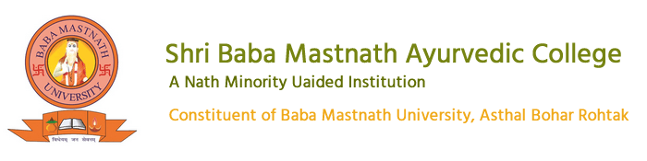

**DABUR INDIA LTD.**

**VISIT SUMMARY**

BAMS 2nd prof students of SBMN Ayurvedic College went for an educational trip at Dabur India Limited, Sahibabad on 16th May 2024.

The objective was to provide students the practical application of pharmaceutical knowledge. The visit started at 7.00 AM along with 60 students with 2 faculties Dr. Austluxmi and Dr. Nitin Jain. We were reached at 11.00 AM.

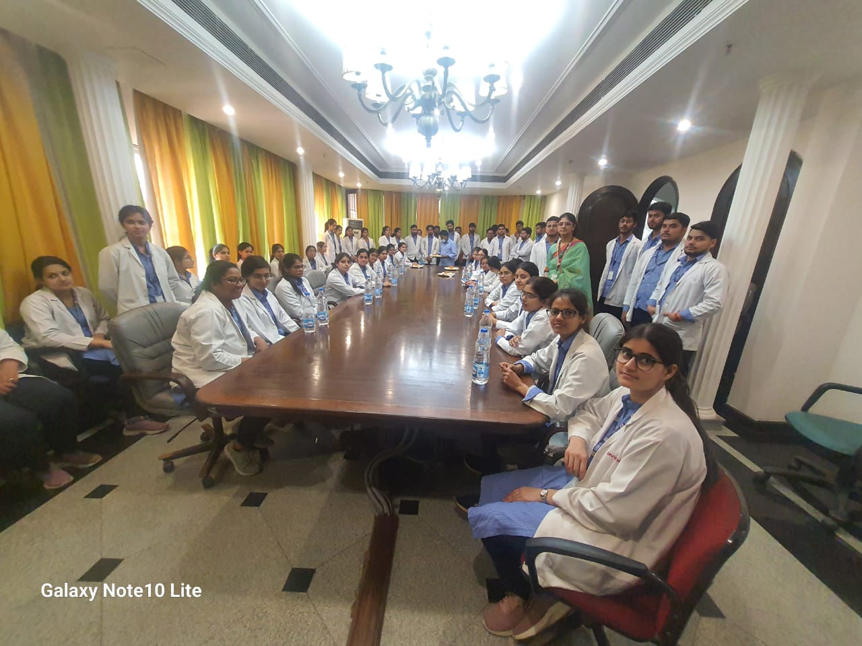

After reach at centre, we had prime interaction with Dr Ajit (advisor of Dabur), Mr. Pradeep (District manager), Mr. Vinod (sales head), Mr. Vaidyanath (Head of R & D). Dr Ajit introduces by prime presentation with the details of Dabur and also about the different departments. We had started visit with research and development section of the pharmacy and provided valuable insights into the practical application of pharmaceutical knowledge.

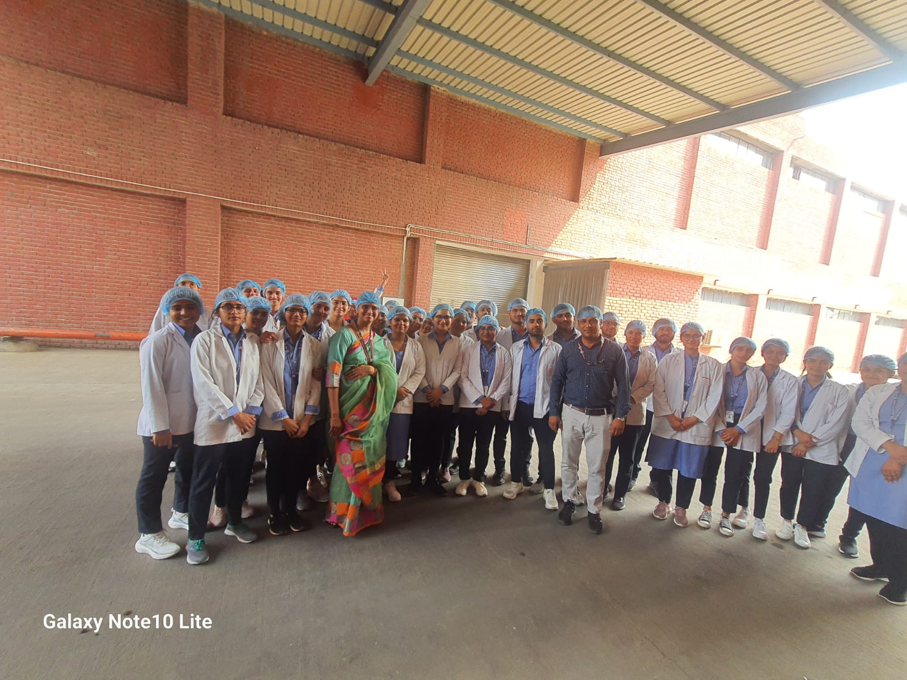

There were different labs designed for different researches like bioresource lab where facility equipped for the study, preservation and utilisation of biological resource. Another lab is analytical lab where primary purpose is to perform qualitative and quantitative analysis of samples to determine their composition, properties and characteristics. There is a stability chamber for conducting stability studies and the primary purpose is to mimic real world storage condition to evaluate how pharmaceutical products degrade and change over time.

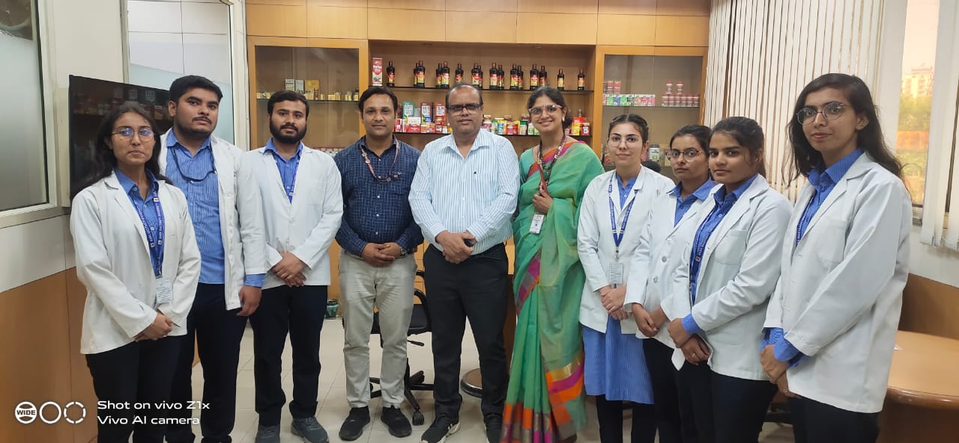

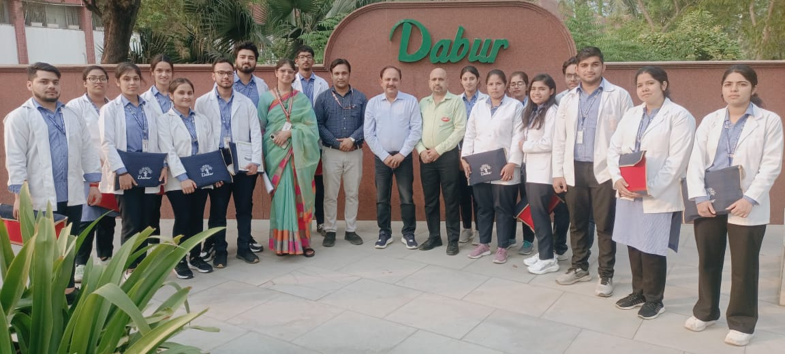

There is separate section for pharmacy library where all manuscripts, API, USP, BP, EP are available.

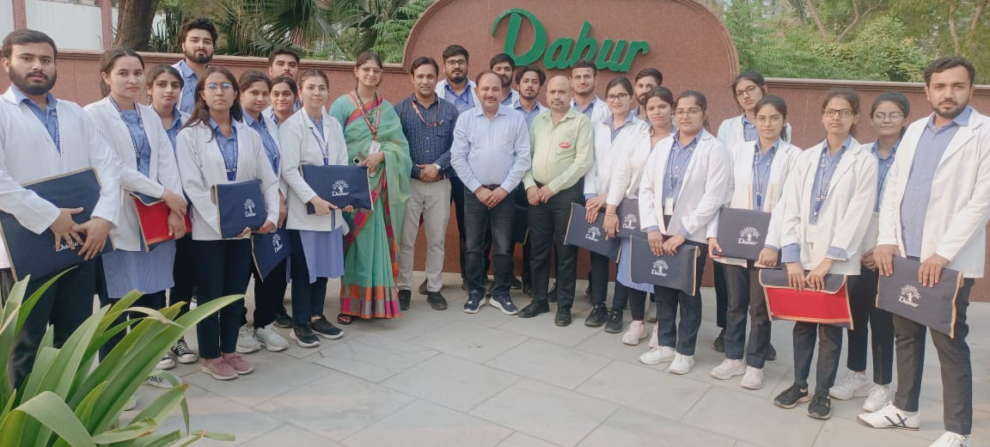

The visit was very useful for the students as they could now relate this theoretical knowledge with the practical exposure, which they have gained after visiting this pharmacy. It was a good learning experience for the students.